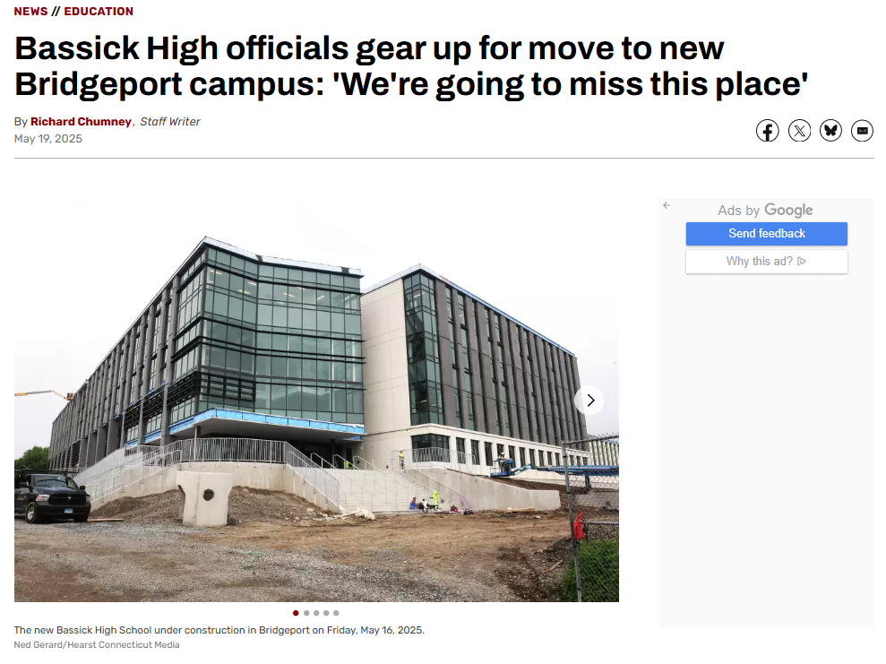

BRIDGEPORT — Bassick High School Principal Joseph Raiola is relying on a pair of six-page spreadsheets to help keep track of the dozens of boxes filled with supplies bound for the school’s brand new campus in the South End.

0:12

/

0:15

Skip AFor much of the past two months, staff members at the nearly 100-year-old school have been cataloging and boxing up textbooks, equipment and other items as the district prepares to decommission the historic Fairfield Avenue building.

“When we started back in March, we really hit the ground running,” Raiola said in an interview this week. “Everybody is pulling together to make sure that the building is prepared to transition out of properly.”

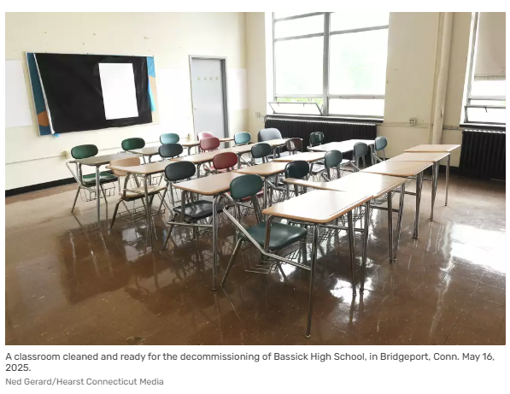

The closing of the school marks the first time the district has decommissioned a building after [Bridgeport](https://www.ctpost.com/news/bridgeport/)officials learned in 2023 that the old Harding High School on Central Avenue [remained packed](https://www.ctpost.com/news/article/condition-abandoned-harding-high-school-stuns-17844059.php) with furniture and a host of supplies despite [closing its doors](https://www.ctpost.com/local/article/Harding-alumni-say-goodbye-to-their-old-school-12998775.php) five years earlier.

The revelation that potentially valuable equipment was sitting unused outraged some members of the City Council and Board of Education and prompted the district to overhaul its approach to retiring old facilities.